**Oracle Gateway Setup for new ODCB connections:**

Server Name: VMOLDEVAP819

**Step 1) Make sure all ODBC connections enter in the following Location:**

Location: /home/oacle/.odbc.ini

For Example: If a new entry or service  called ‘DEV2_SAMPLE’ in a database name ‘SAMPLEDB’  on a server instance  ‘vmwdev2db2202.dosdev.local\DEV2’  to be created,  Following entry to be added to the file

*[DEV2_SAMPLE]*

*Driver=/opt/microsoft/msodbcsql18/lib64/libmsodbcsql-18.1.so.2.1*

*database=SAMPLEDB*

*Server=vmwdev2db2202.dosdev.local\DEV2*

*TrustServerCertificate=Yes*

Here are the contents of existing services:

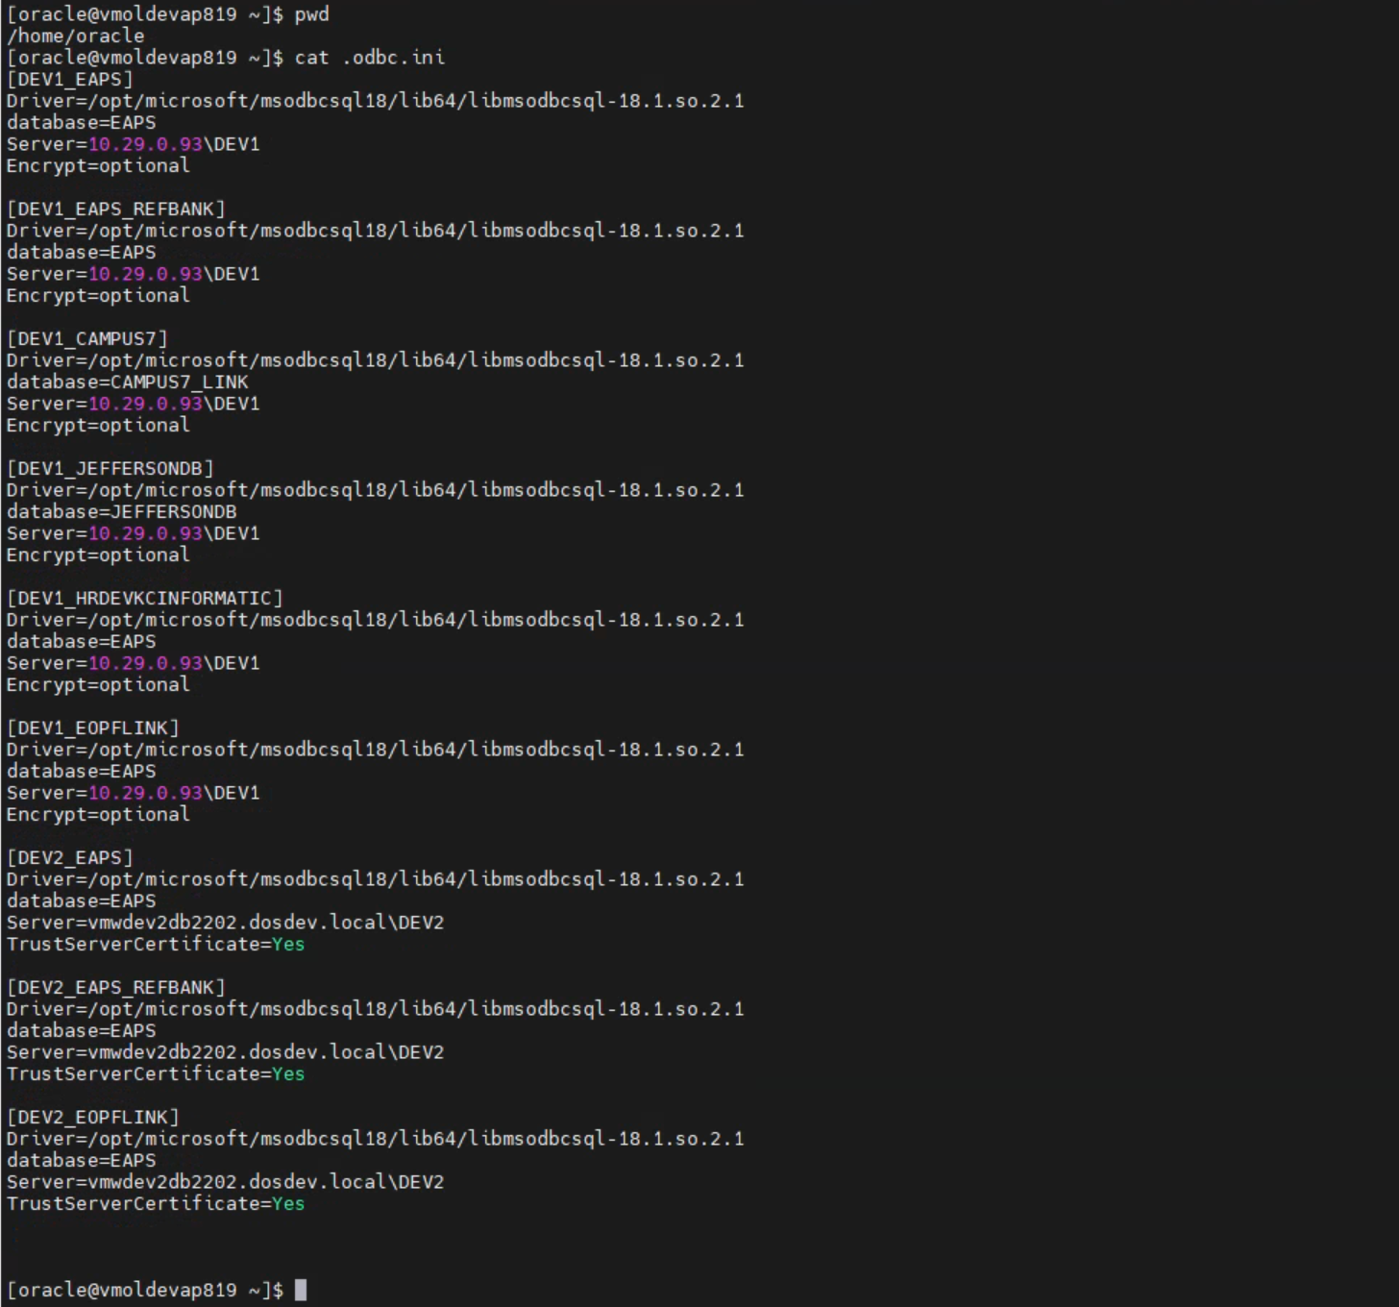

**Step 2) Add entry to Listener.ora :**

Location: /u02/app/oracle/product/19.3.0/gw_1/network/admin/listener.ora

For Ex:

   (SID_DESC =

       (PROGRAM = dg4odbc)

       (SID_NAME = DEV2_SAMPLE)

       (ORACLE_HOME = /u02/app/oracle/product/19.3.0/gw_1)

        )

Existing entries are shown below:

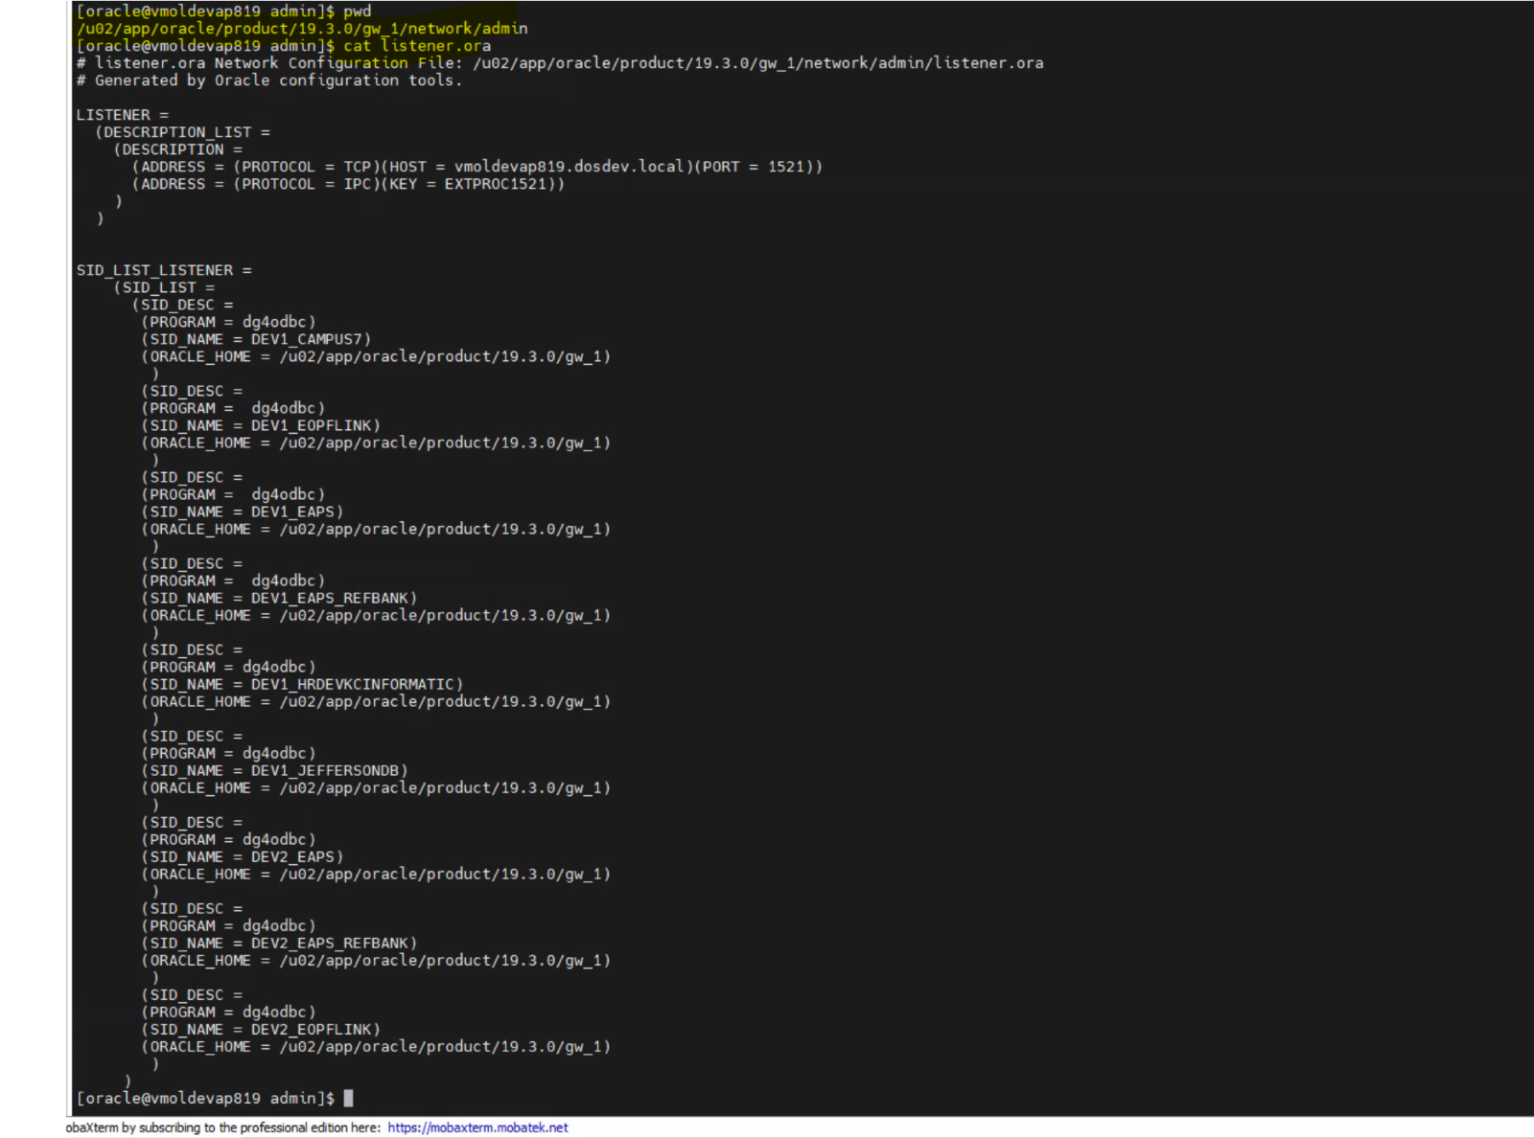

**Step 3) Create a new file for the service :**

Location: /u02/app/oracle/product/19.3.0/gw_1/hs/admin/

Create a File called ‘init*DEV2_SAMPLE.ora’  with following entries in above location:*

# This is a sample agent init file that contains the HS parameters that are

# needed for the Database Gateway for ODBC

#

# HS init parameters

#

#HS_FDS_CONNECT_INFO = <odbc data_source_name>

#HS_FDS_TRACE_LEVEL = <trace_level>

#HS_FDS_SHAREABLE_NAME = <full path name of odbc driver manager or driver>

#

# ODBC specific environment variables

#

#set ODBCINI=<full path name of the odbc initilization file>

#

# Environment variables required for the non-Oracle system

#

#set <envvar>=<value>

HS_LANGUAGE=AMERICAN_AMERICA.WE8ISO8859P1

HS_NLS_NCHAR=UCS2

HS_FDS_CONNECT_INFO= *DEV2_SAMPLE*

##HS_FDS_TRACE_LEVEL=DEBUG

HS_FDS_SHAREABLE_NAME=/usr/lib64/libodbc.so

HS_FDS_FETCH_ROWS=1

#

# ODBC specific environment variables

#

set ODBCINI=/home/oracle/.odbc.ini

Existing entries are shown below:

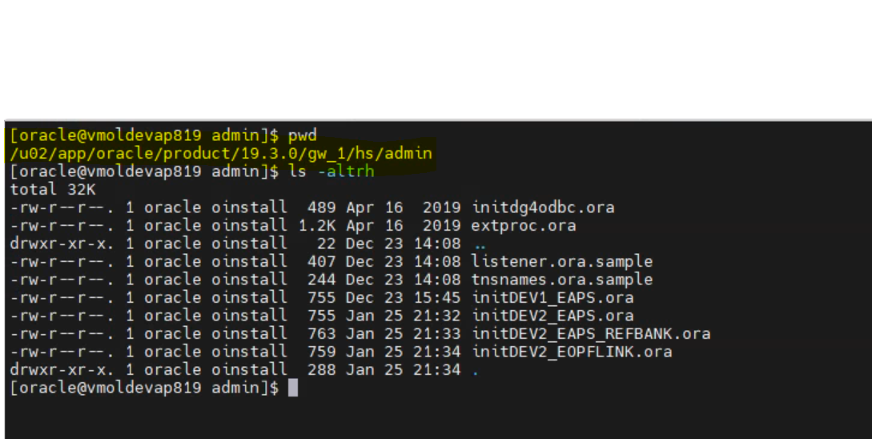

**Step 4: Reload the Gateway listener**

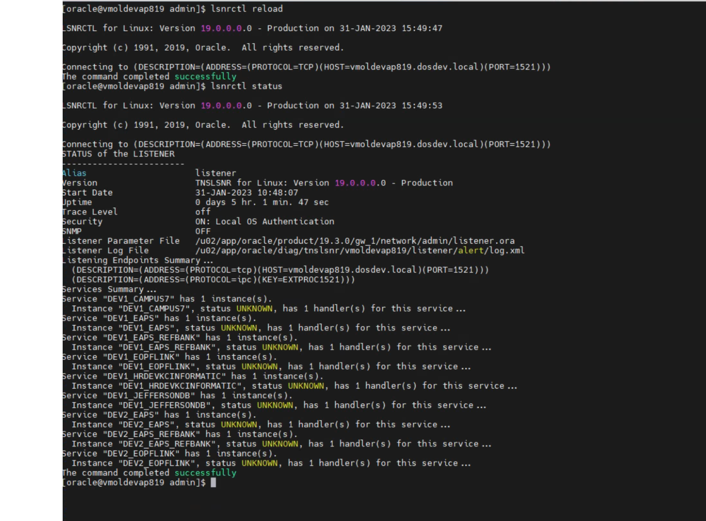

**Step 5: Setup Monitor job to monitor GateWay listener:**

Following Crontab monitor job is setup and scheduled to run every minute. Job checks listener status every minute. It starts the listener if it’s down for any reason*:*

